**How to install & update Sophos Anti-Virus**

Double click SophosSetup.exe file to open

Select yes

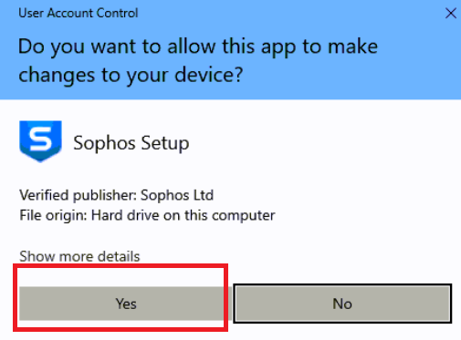

Click continue

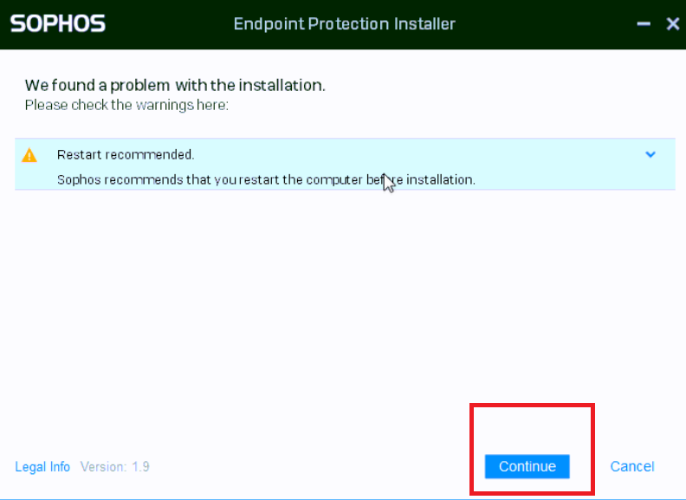

Click install

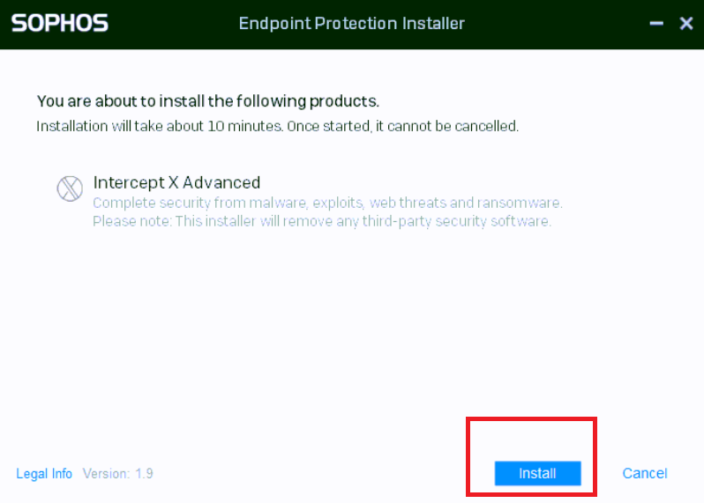

The download will take approximately 10 minutes & you will be required to restart the pc once the install has completed. You will be prompted on screen at this time.

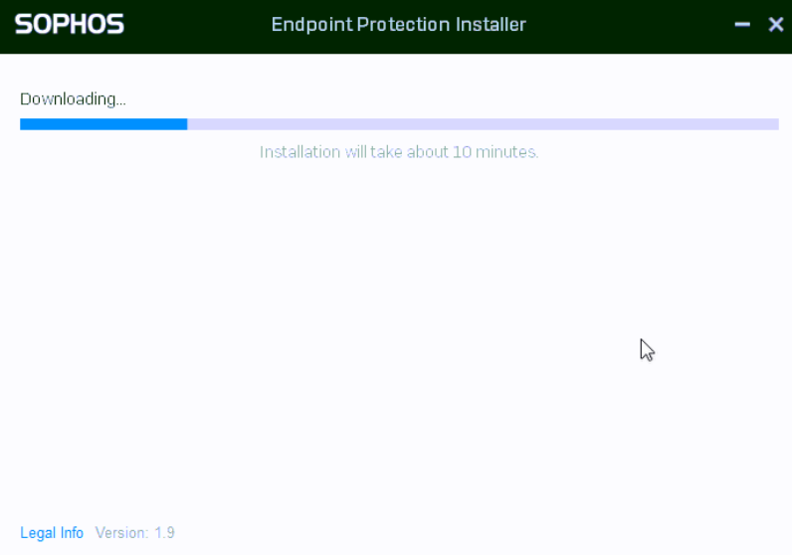

Once the pc has restarted. Click the Sophos icon on your task bar and click '**Update Now**' after this Sophos antivirus will be installed and updated.